UGANDA CERTIFICATE OF LOWER EDUCATION

INFORMATION AND COMMUNICATION TECHNOLOGY

THEORY PAPER

PAPER I

2 Hours 15 Minutes

Attempt All Questions In This Paper

SENIOR THREE

1. Your former primary school administered end of term II 2023 for Primary Seven. The class

teacher approaches you to prepare report cards for these learners.The learners scored as follows;

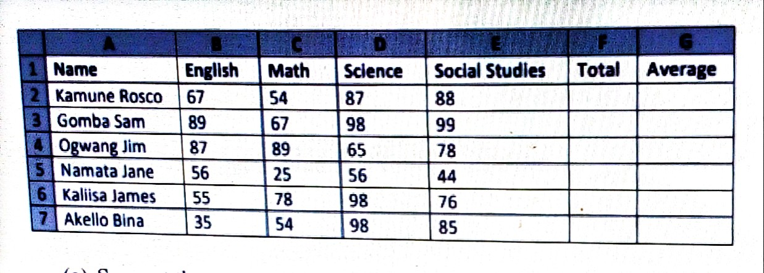

(a) Suggest the appropriate application program to be used to make the above entries

……………………………………………...…………………………………

(b) How many rows and columns are in the table?

(i) Rows

…………………………………………….…………………………………

(ii) Columns

……………………………………………...…………………………………

(c) State the range for the scores

………………………………………………………………..………………

(d) Write down the formulae for computing;

(i) Total marks

……………………………………….………………………………………

(ii) Average marks

……………………….………………………………………………………

(iii) Highest total mark

………………………………………………………………………………

(iv) Lowest score in Math

……………………………………………………………………………

2. John’s father secured a computer set with several peripherals and reserved a special room where

his family members are to practice, learn and do academic research.

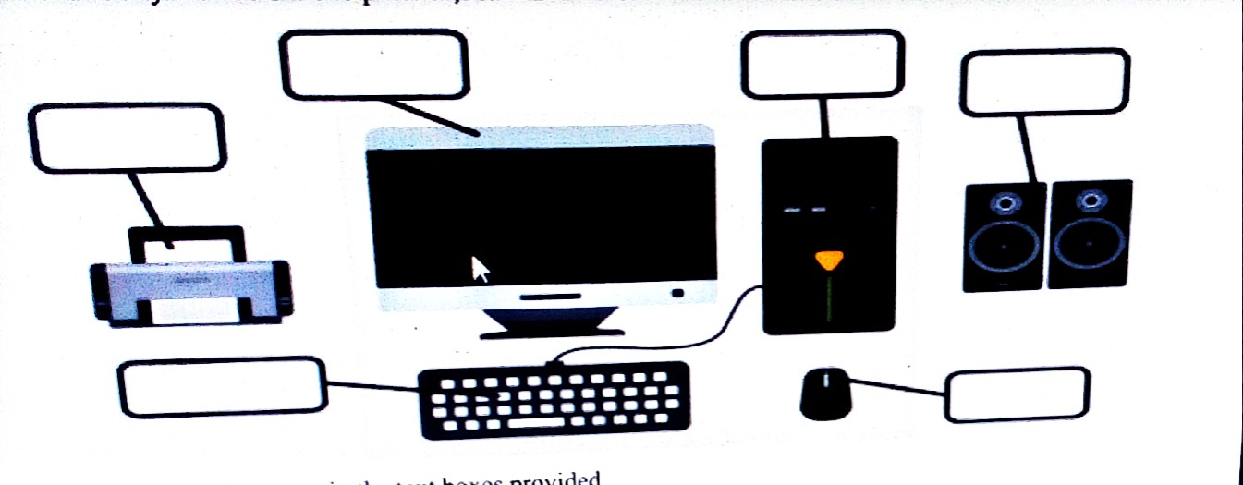

(a) Label the parts in the text boxes provided

(b) Make a clear write up of how you would help the family to connect all the above parts to have

it function, mentioning the names of the cables

……………………………………………...……………………………………………………………………………………………………………….

……………………………………………...……………………………………………………………………………………………………………..

……………………………………………...………………………………………………………………………………………………………………..

(c) John became addicted to the computer and started experiencing some health complications.

State the complications and the possible advice to curb each.

(i) Health complication

………………………………………………………………………………………………………………………………………………………………

Advice

………………………………………………………………………………………………………………………………………………………………...

(ii) Health complication

…………………………………………………………………………………………………………………………………………………………….

Advice

………………………………………………………………………………………………………………………………………………………………

(d) Present the dos and don’ts to protect the family members while in that room

(i) ………….……………………………………………………………………

(ii)

……………………………….………...……………………………………

(iii)

…….…………………………………...……………………………………

3. Mr. Timothy writes a letter seeking for a job opportunity from BUBINGA high school as below.

TIMOTHY KAKELEWE

SAZA RD, IGANGA

0788888777

22ND/NOVEMBER/2023

BUBINGA HIGH SCHOOL

P O BOX 57, BUGWERI

Dear madam,

RE: APPLICATION FOR A TEACHING VACANCY IN YOUR SCHOOL

It is with keen interest to write to you seeking for a teaching opportunity in the department of ICT.

I have taught this subject for now 5 years, having enough expertise to ably handle for the better.

I hold a bachelor’s degree in computer education from kkk-university, all the academic credentials

and CV are attached to this letter.

Since abilities and competences can never be discovered without the physical existence of the

individual, I hope to be invited.

YOUR’S FAITHFULLY

JJJJJJ

TIMOTHY KAKELEWE

0788888777

(a) State the application program he used to write this letter

………………………………………………………………………………

(b) Mention any three features of the application he used to emphasize some parts of the letter.

(i) ………………………………………………………………………………

(ii) ………………………………………………………………………………

(iii) ………………………………………………………………………………

(c) Write the keyboard combination to make the address of the addressor to appear where it is

………………………………………………………………………………